Science: Chemistry
Milestone 3 - Physics - To investigate materials (6 indicators)

Year Group/Class: Elm  Term: Spring Term 1 2023 | Topic: Materials
Prior Knowledge/Teaching: (What does this unit build on?)
Milestone 1: Distinguish between an object and the material from which it is made. Identify and name a variety of everyday materials, including wood, plastic, glass, metal, water and rock. Describe the simple physical properties of a variety of everyday materials. Compare and group together a variety of everyday materials on the basis of their simple physical properties. Find out how the shapes of solid objects made from some materials can be changed by squashing, bending, twisting and stretching. Identify and compare the suitability of a variety of everyday materials, including wood, metal, plastic, glass, brick/rock, and paper/cardboard for particular uses.
Milestone 2: Compare and group together different kinds of rocks on the basis of their simple, physical properties. Relate the simple physical properties of some rocks to their formation (igneous or sedimentary). Describe in simple terms how fossils are formed when things that have lived are trapped within sedimentary rock. Recognise that soils are made from rocks and organic matter. Compare and group materials together, according to whether they are solids, liquids or gases. Observe that some materials change state when they are heated or cooled, and measure the temperature at which this happens in degrees Celsius (°C), building on their teaching in mathematics. Identify the part played by evaporation and condensation in the water cycle and associate the rate of evaporation with temperature.
Lenses: What we want children to know (Curriculum) (Chris Quigley Objectives)  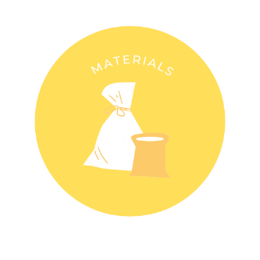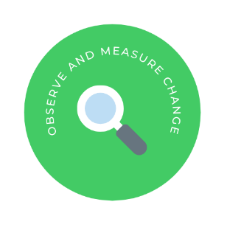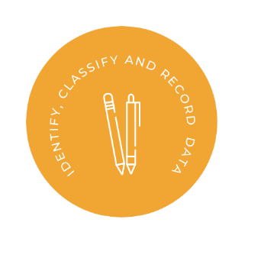  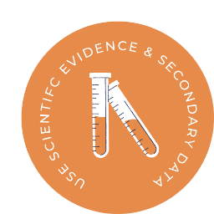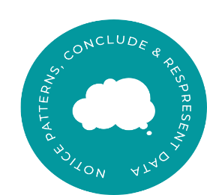 |  | Key Vocab  Properties, hardness, solubility, transparency, electrical conductor, thermal conductor, response to magnets, dissolve, solution, separate, separating, solids, liquids, gases, evaporating, reversible changes, dissolving, mixing, evaporating, filtering, sieving, melting, irreversible, new material, burning, rusting, magnetism, electricity, chemists, quantitative, measurements, conductivity, insulation, chemical, fair test

