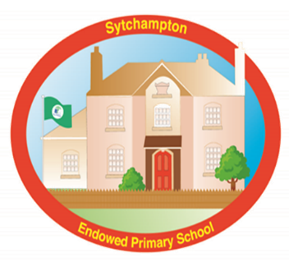

Oak Class (Year 1/2) Curriculum Newsletter
Spring Term 2 2025
Hope you have had a lovely half term. This half term, we will be welcoming Mrs Lawson back from her maternity leave. She will be working Wednesday-Friday each week.
Science: Materials: Uses of Everyday Materials  Geography: Would you prefer to live in a hot or cold place?  Computing: Scratch Jr  Music: Musical symbols  PSHE: Safety and the Changing Body  RE: What is a prophet?  PE: Yoga/sending and receiving    DT: Food – a balanced diet   |  | English  Every morning, we are starting our day with handwriting to make sure we work on our letter formation. This is then followed by phonics and spelling lessons. We have guided reading sessions throughout the week too. We also have a class read book, which is read at the end of every day.  In English lessons, we will be learning about instruction writing. We will be developing our writing and building up to writing our own instructions.  Maths  This half term, we will be moving on to multiplication and division.  Please remember to practise your KIRFS at home and tick them off in the back of your reading diary.  Year 1 - I can count in 2s to 20. I can count in 10s to 100. I can count in 5s to 50.  Year 2 - I know the multiplication and division facts for the 2- 10- and 5-times tables. (Up to 12x)
Reading At Home  Reading takes place in a variety of forms. Children will have phonics, spelling, grammar and guided reading lessons.  Children will come home with a phonics book, which they should be able to read fluently, and a ‘love for reading’ book which is linked to a colour reading band. Phonics books are changed every Tuesday and Thursday, we ask children to change their ‘love for reading’ book whenever they need to.    When reading and sharing a book at home with your child, please try to ask some comprehension questions to ensure they understand what they are reading. |  |  | A note on homework:  Children should be reading daily. They will also be sent home a sheet that contains spellings and maths test for each week.  Spellings are added to Spelling Shed for you to practise each week.
Reminders  P.E. is on a Tuesday, please ensure children come to school dressed in PE kit.  PE kit:  All children need a red t-shirt, black shorts, and black PE pumps. For outdoor PE, they need black tracksuit bottoms, a school sweatshirt or fleece top and trainers or pumps. | These are the words that children learn to spell throughout year one and two  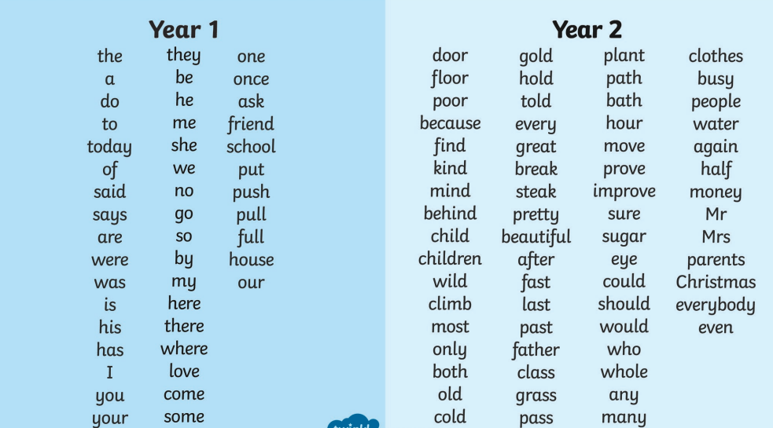

Topic vocabulary:
Geography – continent, climate, polar, equator, temperature, weather
Science – property, material, flexible, metal, glass, plastic

