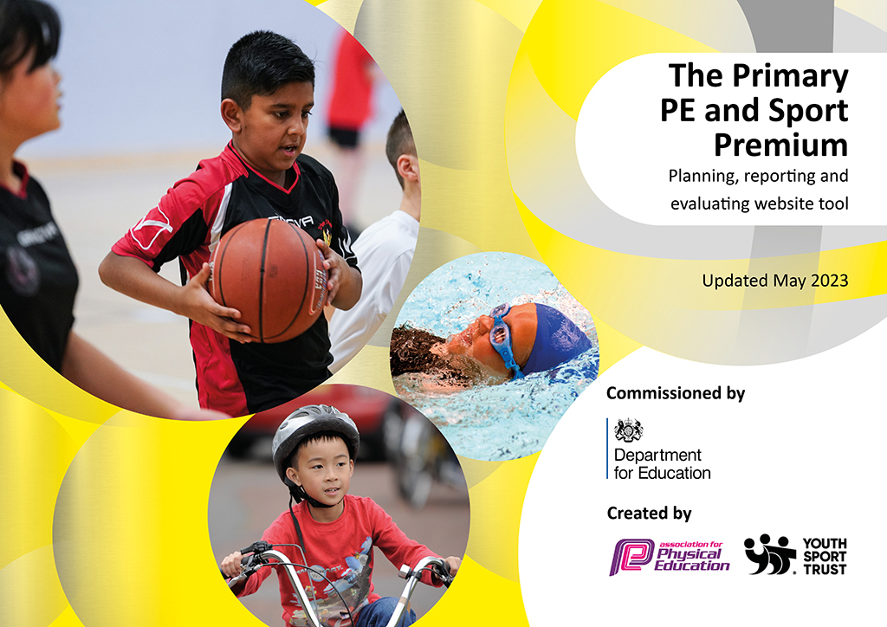
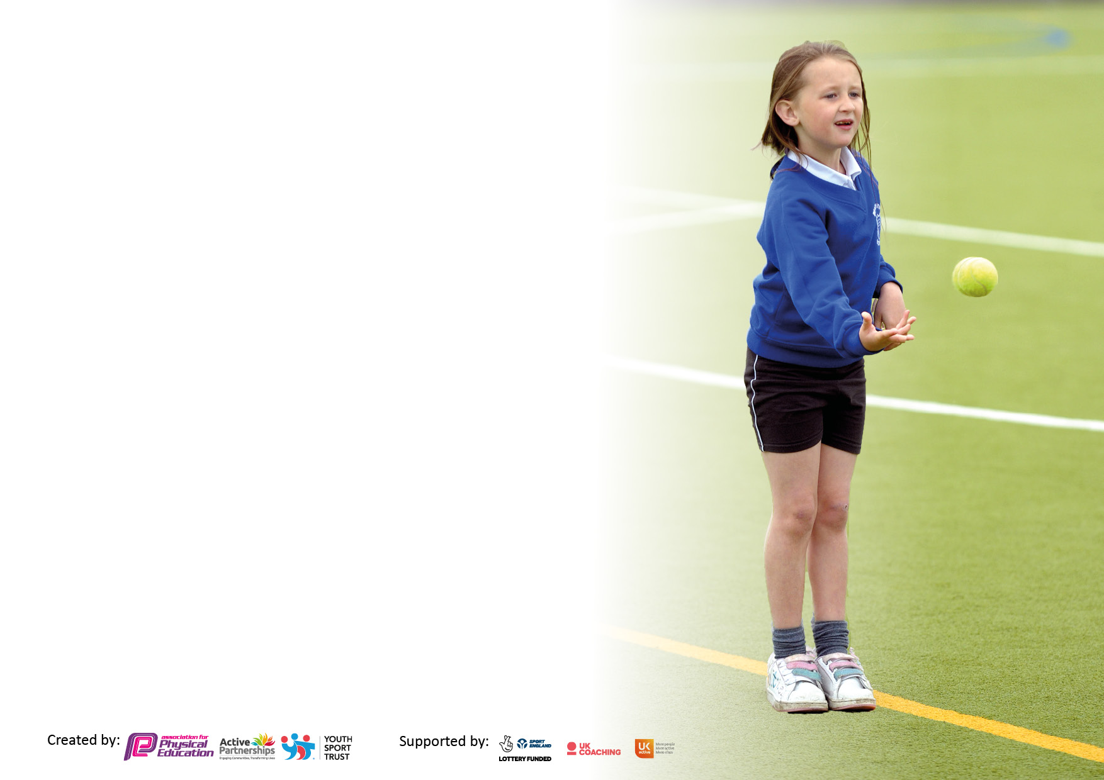

It is important that your grant is used effectively and based on school need. The Education Inspection Framework makes clear there will be a focus on ‘whether leaders and those responsible for governors all understand their respective roles and perform these in a way that enhances the effectiveness of the school’.

Under the Quality of Education Ofsted inspectors consider:
Intent - Curriculum design, coverage and appropriateness
Implementation - Curriculum delivery, Teaching (pedagogy) and Assessment
Impact - Attainment and progress

To assist schools with common transferable language this template has been developed to utilise the same three headings which should make your plans easily transferable between working documents.

Schools must use the funding to make additional and sustainable improvements to the quality of Physical Education, School Sport and Physical Activity (PESSPA) they offer. This means that you should use the Primary PE and sport premium to:

- Develop or add to the PESSPA activities that your school already offer
- Build capacity and capability within the school to ensure that improvements made now will benefit pupils joining the school in future years
- The Primary PE and sport premium should not be used to fund capital spend projects; the school’s budget should fund these.

Pleasevisitgov.ukfortherevisedDfEguidanceincludingthe5keyindicatorsacrosswhichschoolsshoulddemonstrate animprovement.Thisdocumentwillhelpyoutoreviewyourprovisionandtoreportyourspend.DfEencouragesschools to use this template as an effective way of meeting the reporting requirements of the Primary PE and Sport Premium.

We recommend you start by reflecting on the impact of current provision and reviewing the previous spend.

Schools are required to publish details of how they spend this funding, including any under-spend from 2021/2022, as well as on the impact it has on pupils’ PE and sport participation and attainment. All funding must be spent by 31st July 2023.

We recommend regularly updating the table and publishing it on your website throughout the year. This evidences your ongoing self-evaluation of how you are using the funding to secure maximum, sustainable impact. Final copy must be posted on your website by the end of the academic year and no later than the 31st July 2023. To see an example of how to complete the table please click HERE.
Created by: Supported by:

Details with regard to funding
Please complete the table below.

Total amount carried over from 2021/22 | £0
Total amount allocated for 2021/22 | £15870
How much (if any) do you intend to carry over from this total fund into 2022/23? | £0
Total amount allocated for 2022/23 | £16860
Total amount of funding for 2023/23. To be spent and reported on by 31st July 2023. | £ 12803
Swimming Data
Please report on your Swimming Data below.

Meeting national curriculum requirements for swimming and water safety.

N.B. Complete this section to your best ability. For example you might have practised safe self-rescue techniques on dry land which you can then transfer to the pool when school swimming restarts.
Due to exceptional circumstances priority should be given to ensuring that pupils can perform safe self rescue even if they do not fully meet the first two requirements of the NC programme of study
What percentage of your current Year 6 cohort swim competently, confidently and proficiently over a distance of at least 25 metres?  N.B. Even though your pupils may swim in another year please report on their attainment on leaving primary school at the end of the summer term 2022.  Please see note above | 67%
What percentage of your current Year 6 cohort use a range of strokes effectively [for example, front crawl, backstroke and breaststroke]?  Please see note above | 67%
What percentage of your current Year 6 cohort perform safe self-rescue in different water-based situations? | 67%
Schools can choose to use the Primary PE and sport premium to provide additional provision for swimming but this must be for activity over and above the national curriculum requirements. Have you used it in this way? | Yes/No

Action Plan and Budget Tracking
Capture your intended annual spend against the 5 key indicators. Clarify the success criteria and evidence of impact that you intend to measure to evaluate for pupils today and for the future.

Academic Year: 2022/23 | Total fund allocated: | Date Updated:
Key indicator 1: The engagement of all pupils in regular physical activity – Chief Medical Officers guidelines recommend that primary school pupils undertake at least 30 minutes of physical activity a day in school |  |  |  | Percentage of total allocation:
 |  |  |  | %
Intent | Implementation |  | Impact
Your school focus should be clear what you want the pupils to know and be able to do and about  what they need to learn and to  consolidate through practice: | Make sure your actions to achieve are linked to your intentions: | Funding allocated: | Evidence of impact: what do pupils now know and what can they now do? What has changed?: | Sustainability and suggested next steps:
Provide all children with opportunities to become more active, with a focus on engaging the least active pupils | Audit KS2 pupil’s engagement in physical activity and select the least active pupils to target throughout the academic year. Then establish a weekly Games club run by the PE Coordinator.  Create more active break times and lunch times through teacher led activities at break times and play leaders at lunch times. Purchase new equipment in order to do so.  Develop pupils leadership skills. Play leaders and Sports Crew to help run Sports day.  Establish play leaders for the academic year. Initial training provided by the Sports Partnership. PE subject leader to meet with them regularly. Purchase equipment and storage for play leaders.  Increase activity levels during before and after school club by providing the option to join in with Cosmic yoga/Joe Wicks workouts.  All children to participate in a Santa dash.  National Sports Week. Plogging event organized by Sports Crew.  Sports crew to give out 30 active minutes wristbands to all children being active at lunchtimes. | £200  £100  £60 | Games club has been run by RGB sports, Empower Active and the PE Coordinator. Children have enjoyed participating in different activities to increase their activity levels and have noticeably increased during lunch times.  Most children are now active at break times and lunch times. A variety of activities are available at lunchtimes: tennis, basketball/netball, football and activities run by the Play Leaders.  Sports day was well organised and Sports Crew and Play leaders enjoyed developing their leadership skills.  Participation from the younger children has been good during lunchtimes. Most Play Leaders have taken on the role for the whole year and will now work to help train up the Play Leaders for next year.  Some children participated in Joe Wicks workouts after school. Children are outside and have the option to be active as much as possible. We will continue to develop this further next academic year.  All children took part in the run and understood the importance of why running is good for our health.  During National Sports Week, the emphasis was on achieving 30 active minutes within school. All children could join in with a different sport each break time and each class went for a daily run. The Sports Crew organized a daily ‘plogging’ event each lunch time which had high rates of participation. There was also a competition for the most active class as they all tried to achieve 30 active minutes.  The wristbands have been very popular, particularly with the younger children. The children can now talk about what they have done to be active and how long they need to try to be active for. | Assess children’s level of activity next academic year and identify a new focus group of less active children.  Continue to develop the role of Sports Crew and Play Leaders to have a positive impact on activity levels.  The ‘plogging’ event was very popular and children have requested that it becomes a weekly event. Sports Crew are going to continue to organise this.
Key indicator 2: The profile of PESSPA being raised across the school as a tool for whole school improvement |  |  |  | Percentage of total allocation:
 |  |  |  | %
Intent | Implementation |  | Impact
Your school focus should be clear what you want the pupils to know and be able to do and about  what they need to learn and to  consolidate through practice: | Make sure your actions to achieve are linked to your intentions: | Funding allocated: | Evidence of impact: what do pupils now know and what can they now do? What has changed?: | Sustainability and suggested next steps:
Develop more opportunities for leadership roles.  Ensure parents are regularly informed of what PE and school sport we are doing in school. | Create a ‘sports news’ section on the school website to promote school sports.  Regularly promote PE success on the school website, newsletter and social media.  Award play leaders at the end of the year for showing good leadership and demonstrating our school values.  Establish a sports crew to raise the profile of PE in the school and assist with organising events. Sports crew to do a whole school assembly and organise an eco-friendly event in the summer term.  Establish wellbeing champions who meet regularly and are involved in the planning of many events throughout the year.  Run a nurture club and purchase resources.  Olympian Matt Richards to do a whole school assembly and answer questions from the children. Emphasis on how you need resilience and to persevere to become successful.  New houses put in place. Children receive house points for inter tournaments and sports day.  PE subject leader to have weekly management time to develop PE.  Sports day stickers | £50  £100  Nurture club resources - £200  Subject leader 1.5hours release time per week:  £2423  £33 | The PE and Sport Premium section of the website now contains a summary of the year. This will continue to be developed next year to showcase all that we do.  Parents and pupils are made aware of sports events within school and externally. Parents and children have been made aware of our focus on ’30 active minutes’  Lunchtimes are now more varied with Play Leaders able to organise a range of different activities. Behaviour has improved due to a more structured environment outside.  Sports Crew have done an excellent job of raising the profile of PE. They did a whole school assembly, a school questionnaire, organised handing out 30 active minutes wristbands each lunchtime and organised a ‘plogging’ event.  Wellbeing champions have played an active role throughout the year which has culminated in organising a whole school ‘wellbeing day’.  Participation is high at nurture club. Children enjoy taking part in a variety of activities, such as planting seeds, making sensory bottles etc.  All children enjoyed the chance to speak to Matt Richards. The assembly focused on how resilience and perseverance can lead to success and how that can be translated into a school environment.  All children are aware of their houses – all named after famous sports people. They have benefited from the introduction of a more competitive element.  PE subject leader has re-mapped the curriculum, organised sporting competitions, run Games club, created more active breaks and lunchtimes and developed ideas to increase children’s engagement in activity. | Continue to develop leadership roles and staff to share good practice.

Key indicator 3: Increased confidence, knowledge and skills of all staff in teaching PE and sport |  |  |  | Percentage of total allocation:
 |  |  |  | %
Intent | Implementation |  | Impact
Your school focus should be clear | Make sure your actions to | Funding | Evidence of impact: what do | Sustainability and suggested
what you want the pupils to know | achieve are linked to your | allocated: | pupils now know and what | next steps:
and be able to do and about | intentions: |  | can they now do? What has
what they need to learn and to |  |  | changed?:
consolidate through practice:
Provide a robust PE scheme of work that provides a clear progression of knowledge and skills.  Provide professional development opportunities for teachers in PE and sport. | New PE scheme (Get set 4 PE) purchased. PE Subject leader to provide support when needed.  RGB sports to deliver PE lessons to all classes for Autumn 1. All teachers to participate in the lesson for CPD purposes. RGB to deliver Fundamental movement skills/athletics units of work.  Empower active sports coaches to work with all year groups.  Chance 2 shine CPD for Y1/2 and Y5/6.  Additional individual targeted CPD to target areas of development identified from staff audit.  Member of staff to attend Level 3 Forest School course. | £1375  £1350  £1360  £612  Provided by sports partnership.  £690 | Staff are confident using the new scheme and the scheme provides a good progression of knowledge and skills throughout the units of work.  All staff have received two CPD for two units and report increased confidence.  Empower active coaches provided yoga CPD to Y1/2 and Y3/4 teachers. Provided tag rugby to Y5/6 and ball skills to Reception teachers.  ECT to attend training in dance and gymnastics.  Y3/4 completed LTA training before delivering a tennis unit of work.  Forest School will now be implemented across all year groups next year. Currently being trialed with Reception. | Commence forest school sessions for all year groups throughout the next academic year.
Key indicator 4: Broader experience of a range of sports and activities offered to all pupils |  |  |  | Percentage of total allocation:
Intent | Implementation |  | Impact
Your school focus should be clear | Make sure your actions to | Funding | Evidence of impact: what do | Sustainability and suggested
what you want the pupils to know | achieve are linked to your | allocated: | pupils now know and what | next steps:
and be able to do and about | intentions: |  | can they now do? What has
what they need to learn and to |  |  | changed?:
consolidate through practice:
To create a new PE pathway that allows for progression of skills and provides opportunities for children to experience a range of different sports.  To promote links with new sports coaches and clubs. | Purchase new equipment to support the new Get Set 4 PE scheme of work.  PE pathway adapted to allow for two units per half term and 2 hours of curriculum PE per week.  Tennis, netball, dance, cricket and golf extra-curricular clubs provided throughout the year.  Bikeability provided to all Year 4 pupils | £800 | We now have equipment to support the learning for all units on the PE Curriculum Pathway.  New curriculum pathway is now being implemented, children are developing their fundamental movement skills and learning builds on prior learning.  Children have participated in a greater range of extra-curricular clubs. Football club was provided following a pupil questionnaire organised by Sports Crew showed that most pupils would like a football club.  All year 4 pupils are now more confident when riding a bike. | Fund extra-curricular clubs for least active children.  Create links with new club providers, e.g. fencing, rugby in order to increase participation in extra-curricular clubs.

Key indicator 5: Increased participation in competitive sport |  |  |  | Percentage of total allocation:
 |  |  |  | %
Intent | Implementation |  | Impact
Your school focus should be clear | Make sure your actions to | Funding | Evidence of impact: what do | Sustainability and suggested
what you want the pupils to know | achieve are linked to your | allocated: | pupils now know and what | next steps:
and be able to do and about | intentions: |  | can they now do? What has
what they need to learn and to |  |  | changed?:
consolidate through practice:
Consistent running of Level 1 sport competitions and increasing pupils’ participation in Level 2 (including B and C teams). | All KS2 year groups to participate in House tournaments per year (Intra).  Participate in range of Sport Partnership school games events (Inter)  Hold a School Games day/Sports day in the Summer term. | Sport Membership: £2250  Transport to events: £400  Staff cover: £800  Total - £12803 | Y3/4 – Tennis, football  Y5/6 – netball, rounders, cricket  Inter – Reception/Year 1 – Girls football  Y1/2 – Cricket festival  Y3/4 – Bellboating  Tri-golf  Y5/6 – netball  All children competed in sports day in their new houses. | Participate in a greater range of sporting competitions.  Develop inter tournaments now that new Houses are established.

Signed off by
Head Teacher:
Date:
Subject Leader:
Date:
Governor:
Date:

