Animals including Humans Knowledge Organiser

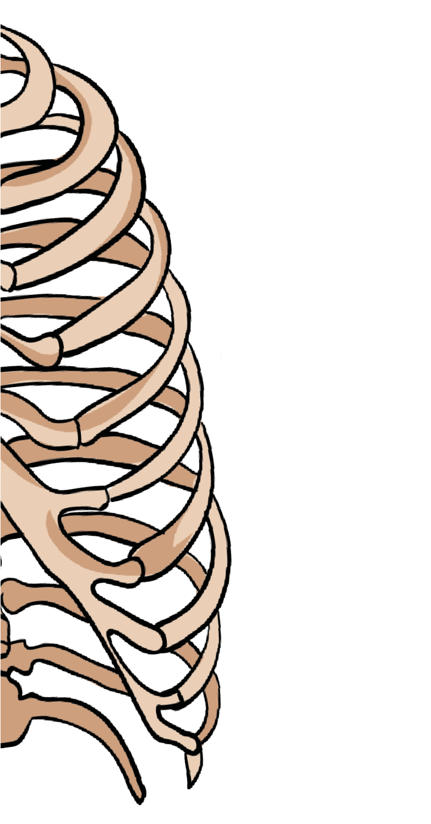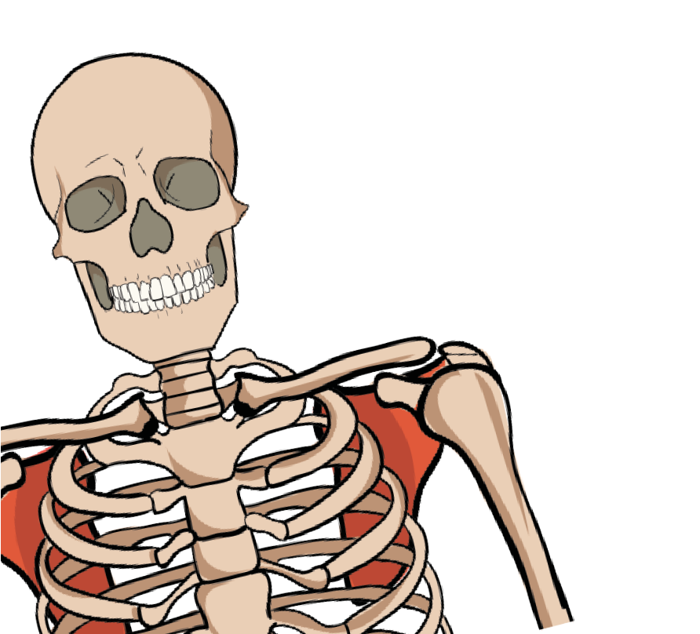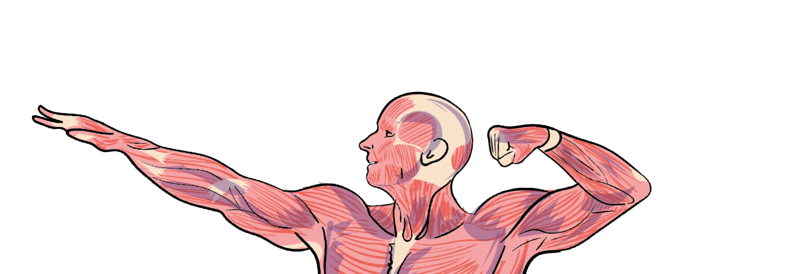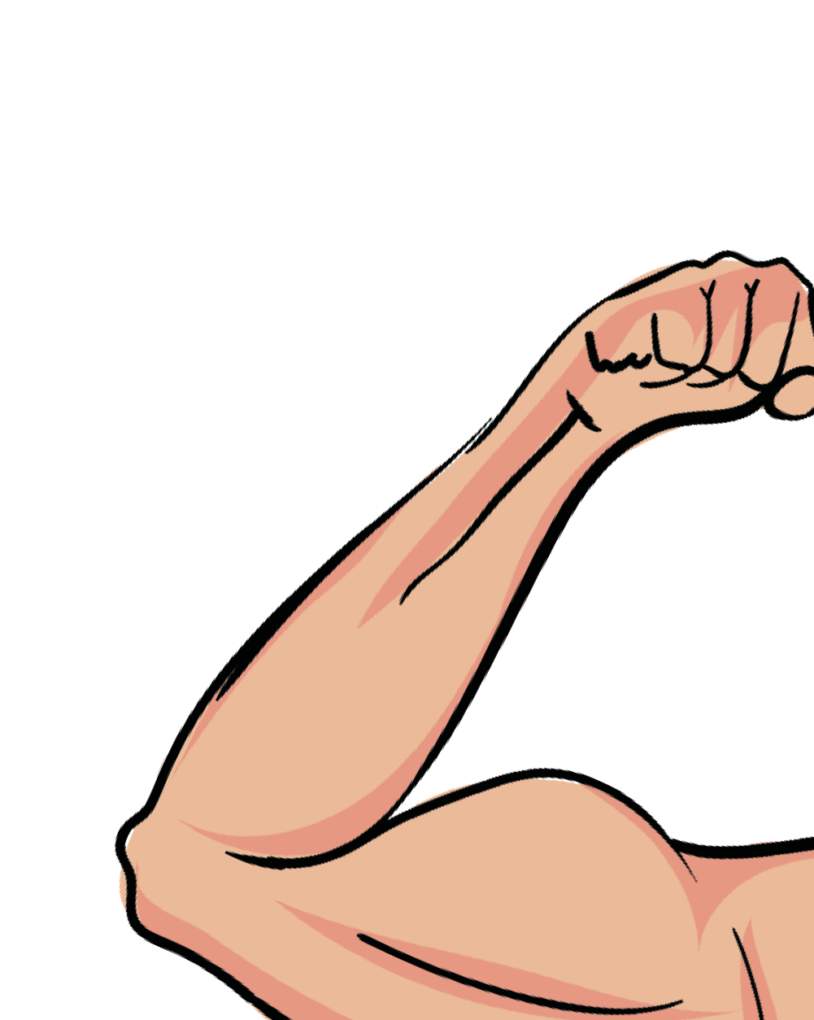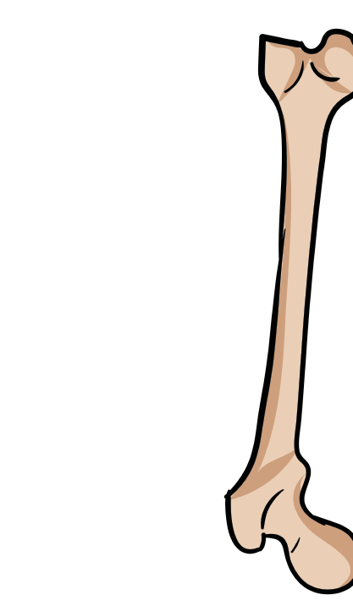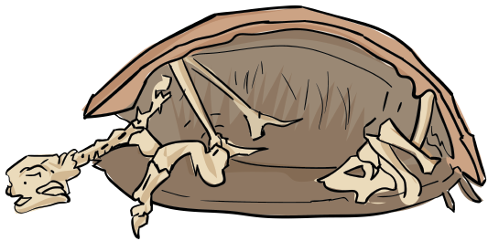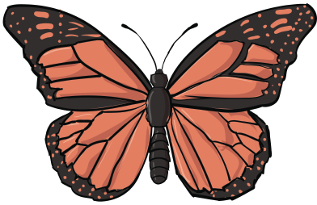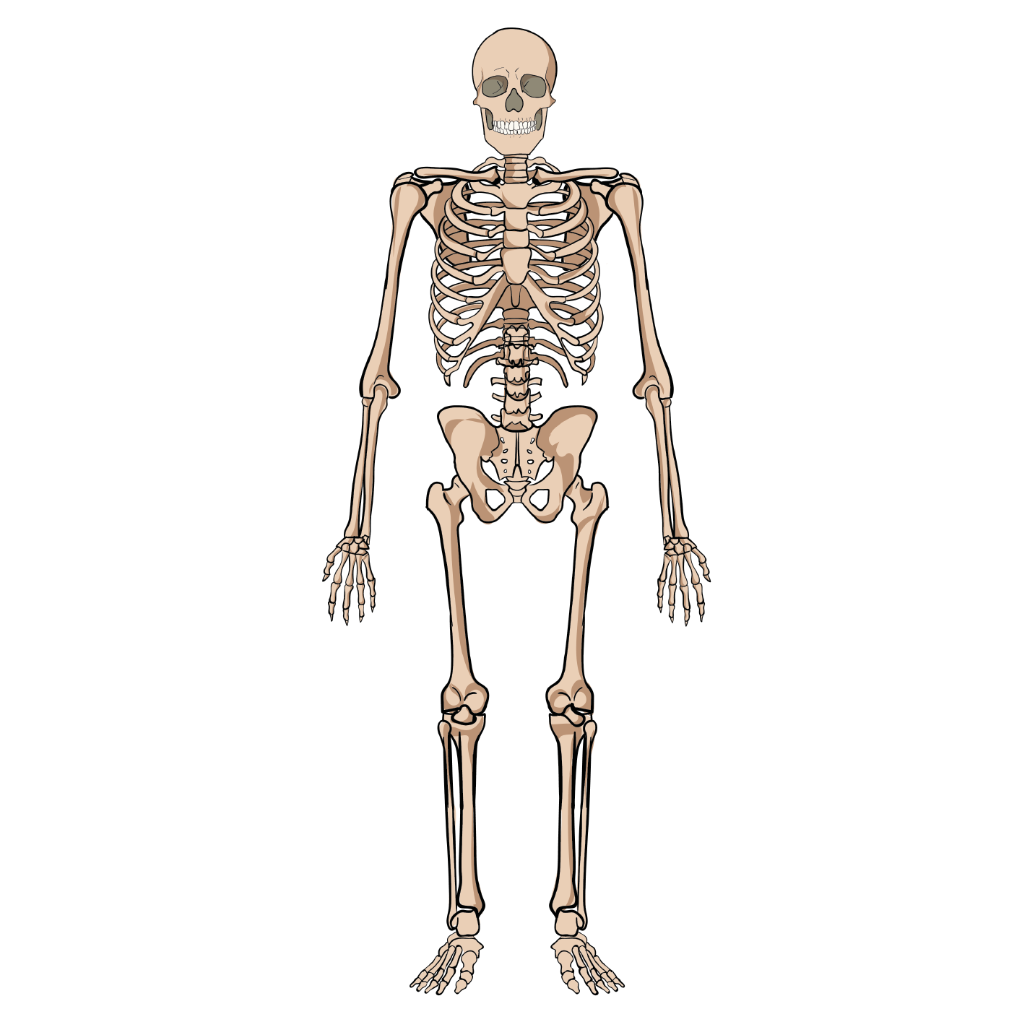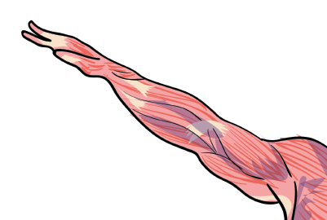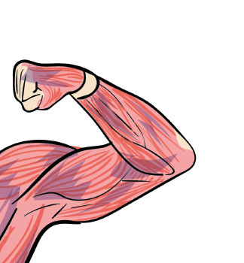

# Bones Other animals

**Vertebrates** are animals that have a spine or backbone as part of their skeleton. Humans are vertebrates.

**collar bone**

**skull**

**Invertebrates** are animal that do not have a backbone. A butterfly is an invertebrate.

**shoulder blade**

**jaw**

**rib cage**

**humerus**

# Muscles

**pelvis**

**ulna**

**spinal column**

To **straighten** our arm, our **biceps relax** and our **triceps contract.** This straightens our arm.

**radius**

To **bend** our arm, our **biceps contract** and our **triceps relax.** This allows us to bend our arm at the elbow joint.

**hip**

**femur**

When we **stretch** our muscles, they become **longer** and **thinner.**

**knee cap**

When we **contract** our muscles, they become **shorter.**

**fibula**

**biceps**

**tibia**

**biceps**

**triceps**

**triceps**

[www.grammarsaurus.co.uk](http://www.grammarsaurus.co.uk/)

# Nutrition Key Vocabulary

**Humans** need to eat a **healthy balanced diet.**

**Nutrition** is when we eat food to **give us energy.** Adults and children need lots of energy to help them **keep moving** and keep their **bodies healthy!**

**Children** also need food to **help them grow.**

The Eatwell **Plate shown** below s a guide to help show us how much of each type of food **we should eat.**

**bone -** hard parts of the skeleton **contract -** to squeeze together **diet -** the food that we eat

**exoskeleton -** a skeleton on the outside of the body **invertebrate -** an animal without a spine/backbone **healthy -** things that are good for our bodies

**muscle -** a bundle of tissue that contracts to allow movement

**nutrition -** the food we eat that gives us energy

**relax -** to become less tense

**skeleton -** a framework of bone to support the body

## fruit & veg carbs & starches

**dairy protein**

## sugar & fats

**unhealthy -** things that are not good for our bodies

**vertebrate -** an animal with a spine/backbone

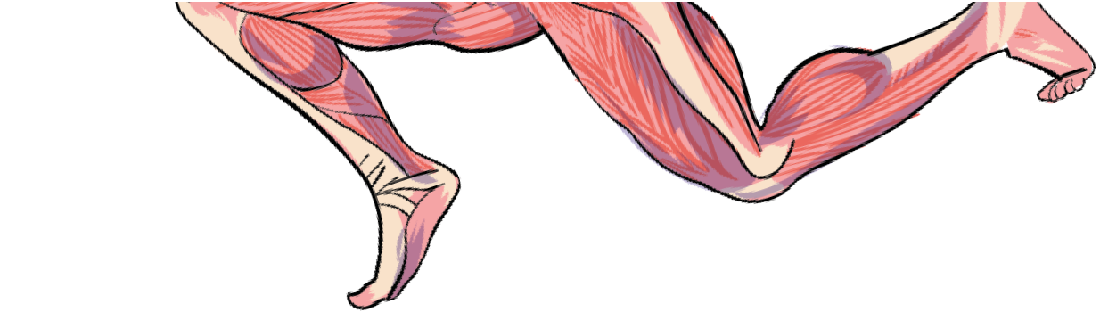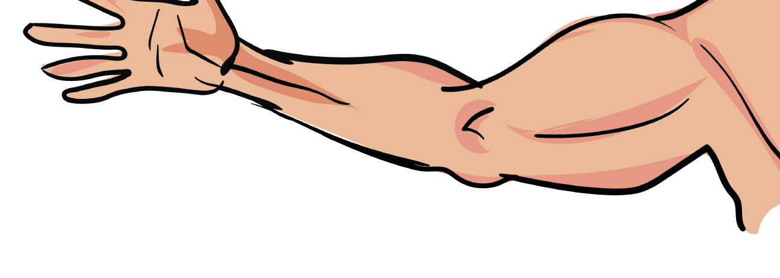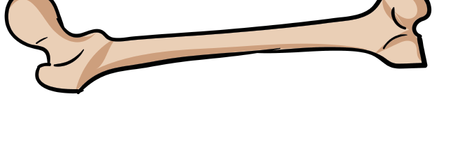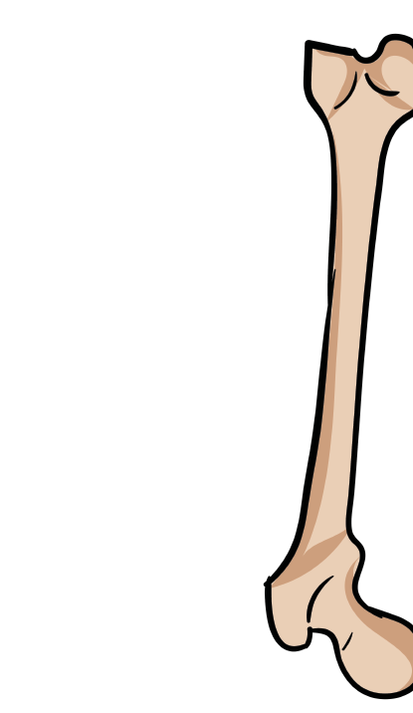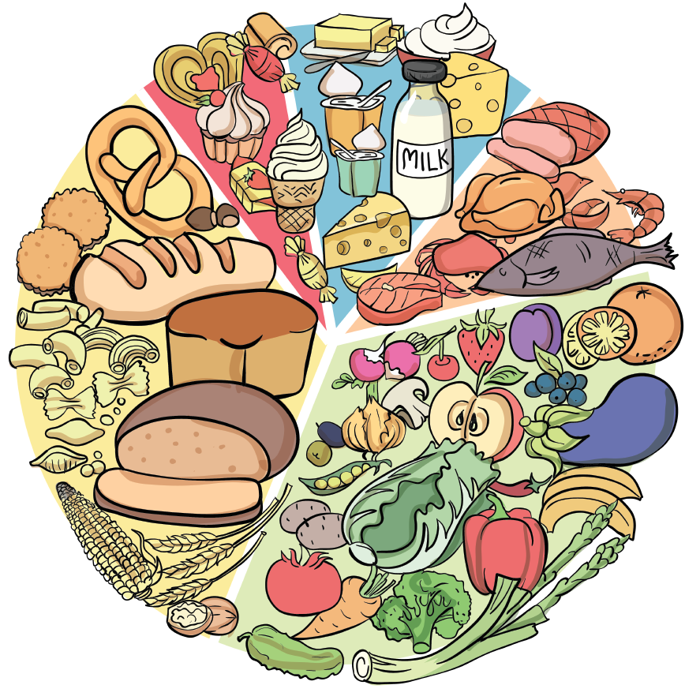

www.grammarsaurus.co.uk