Science Learning Sequence

Year Group/Class: 3/4  Term: Spring 1 | Topic: Materials
Prior Knowledge/Teaching: (What does this unit build on?)  Distinguish between an object and the material from  which it is made.  Identify and name a variety of everyday materials,  including wood, plastic, glass, metal, water and rock.  Describe the simple physical properties of a variety of  everyday materials.  Compare and group together a variety of everyday  materials on the basis of their simple physical  properties.  Find out how the shapes of solid objects made from  some materials can be changed by squashing,  bending, twisting and stretching.  Identify and compare the suitability of a variety  of everyday materials, including wood, metal,  plastic, glass, brick/rock, and paper/cardboard  for particular uses. | Threshold Concepts:  Compare and group together different kinds of rocks on the basis of their simple,  physical properties.  Relate the simple physical properties of some rocks to their formation (igneous or  sedimentary).  Describe in simple terms how fossils are formed when things that have lived are  trapped within sedimentary rock.  Recognise that soils are made from rocks and organic matter.  Compare and group materials together, according to whether they are solids, liquids or gases.  Observe that some materials change state when they are heated or cooled, and measure the temperature at which this happens in degrees Celsius (°C), building on their teaching in mathematics.  Identify the part played by evaporation and condensation in the water cycle and  associate the rate of evaporation with temperature.
Key Vocabulary:  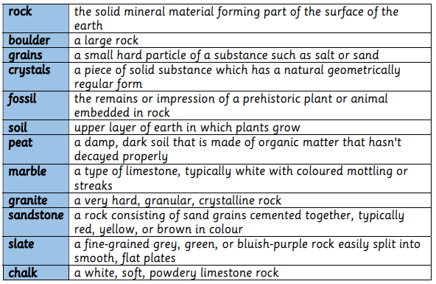 | Learning Lenses: 