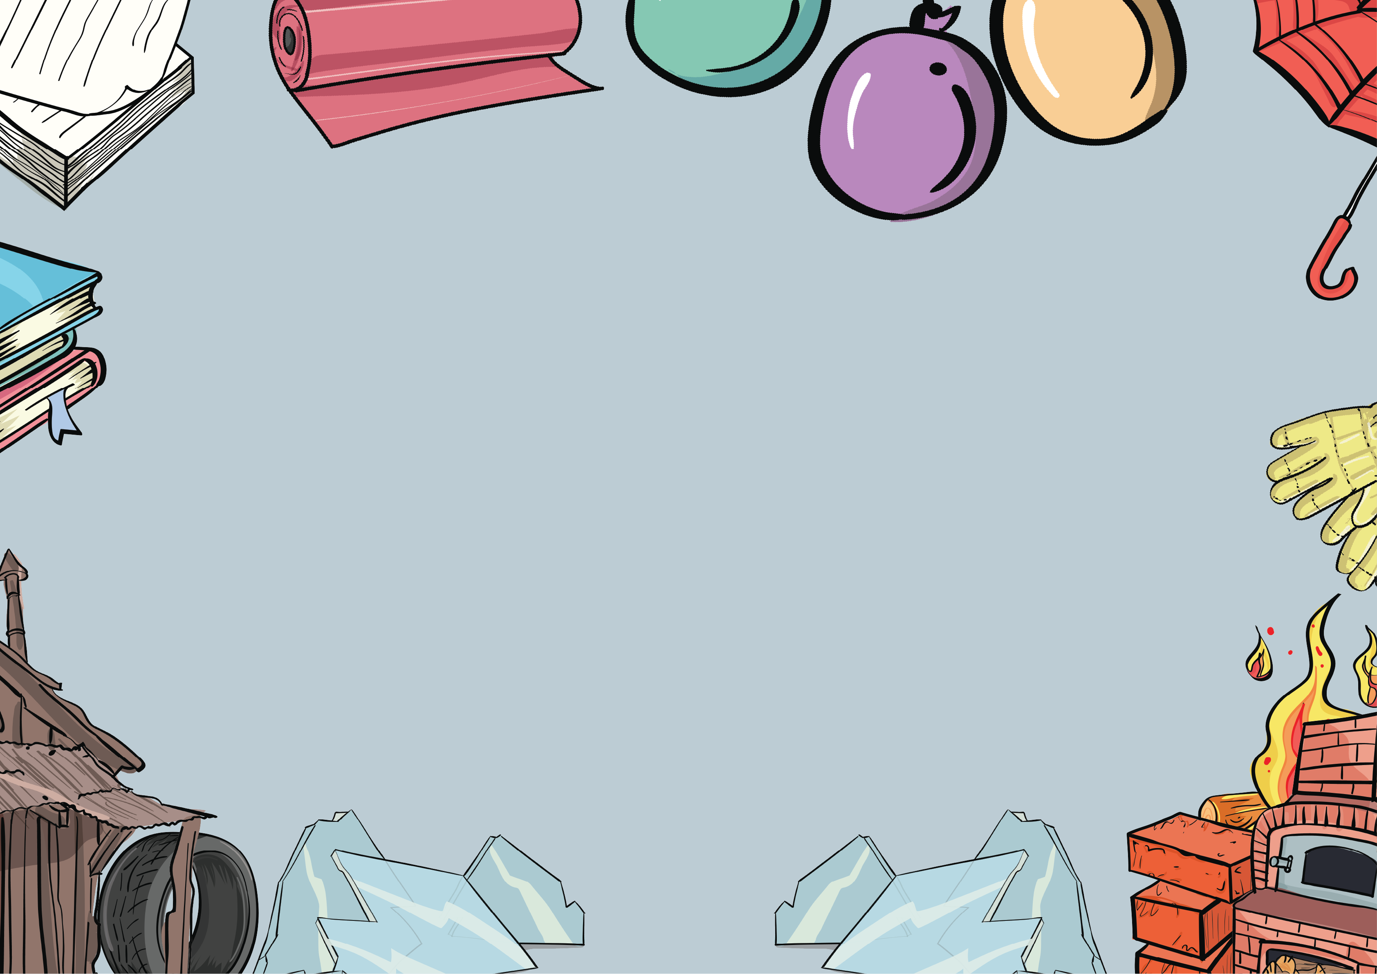

**Everyday Materials**

**Knowledge Organiser**

There are lots of different **types of materials** and they are all good for making different things because they have different **properties.**

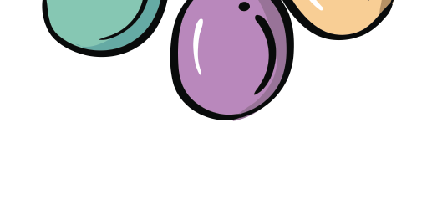

Everyday Materials Knowledge Organiser

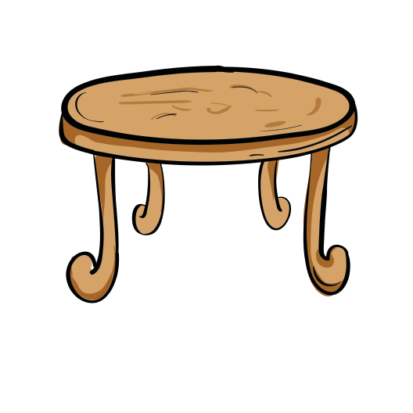

**Wood**

We can make **tables, chairs** and some **toys** from wood because it is **hard.** It can be **rough** or **smooth.**

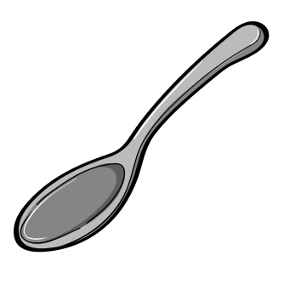

**Metal**

We can make **cars, spoons** and some **musical instruments** from metal because it is **hard** and **smooth.** You can’t see through it.

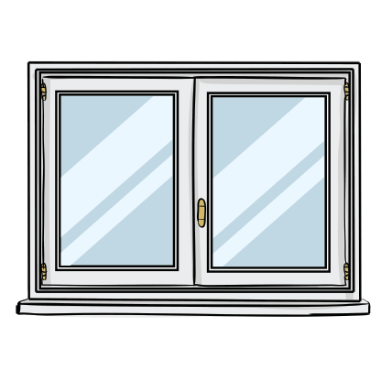

**Glass**

We can make **windows, mirrors** and **glasses** from glass because it hard and see through. It is

very **fragile.**



www.grammarsaurus.co.uk



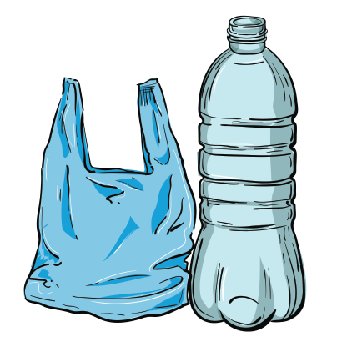

**Plastic**

We can make **toys** and **food packaging** from **plastic** because it is **smooth** and **strong.** It can be **hard** or **bendy.**

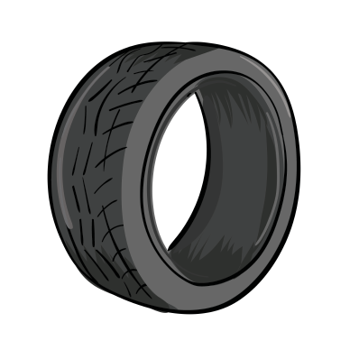

**Rubber**

We can make **wellington boots, car tyres** and **bouncy balls** from rubber because it is squashy and **waterproof.** You can **bend it.**

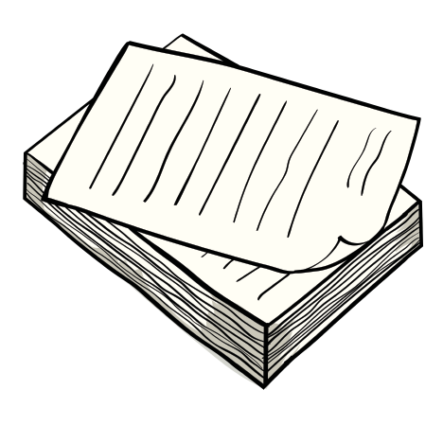

**Paper**

We can make **wrapping paper** and **books** from paper because it is **smooth.** It can tear easily.

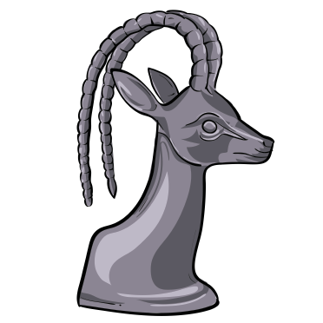

**Rock**

We can make **tiles** and some **jewellery** from rock because it can be **hard.** Some rock can also be **fragile.**

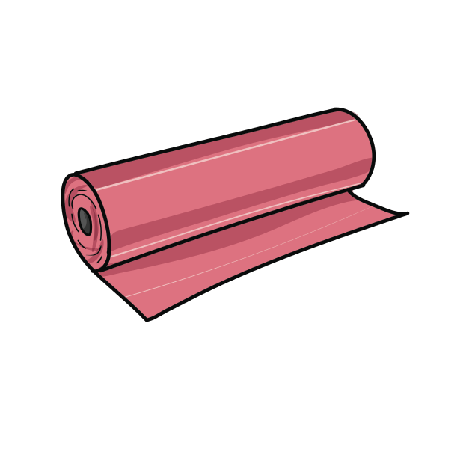

**Fabric**

We can make **clothes** and **bedding** from fabric because it is **soft.** It is usually **smooth.**

www.grammarsaurus.co.uk

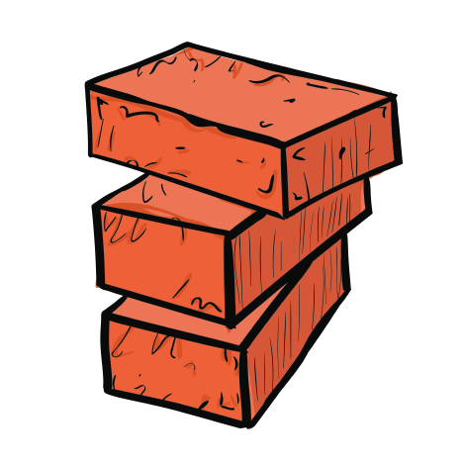

**Brick**

We can make **buildings** from brick because it is very **hard.** It can be **rough.**