

Red Hen School Meals Online Ordering Instructions

Welcome to your new online ordering system for your child’s school meals. This means that you will be ordering school meals for your child directly through Red Hen and not the school.

Please do not register an account before Friday 2nd August.
This will give time for the registration process before you can then begin placing lunch orders from the 5th August.

Please place your orders by Friday 30th August to ensure that your child has a lunch ordered for
the first day of the Autumn term.

We’ve produced this photo and text instructions guide to help you to familiarise yourself with our ordering website.

Please follow the instructions below and before you begin ordering please bear in mind these very important points:

- You will need access to an email account, please sign into your email account and have it open in Tabs so that you can access it whilst you are navigating our website.
- If you pay for your child’s meals, please have your debit/credit card to hand.
- If you have more than 1 child registered on our website; only order meals for 1 child at a time. This means that once you start ordering meals please only do so for 1 child and proceed to the checkout and finish your order before you start ordering for any subsequent child.
- We need a minimum of 5 days notice of your meal order, the ordering system will only allow orders from 5 days ahead, please make sure you order in plenty of time. For example, a meal required on a Monday will need to be ordered on the Wednesday of the week before.
- When an order is placed successfully you will receive a confirmation email. If you do not receive an email then the order has not been completed fully and no meals will be supplied. Please do check your spam/junk folders for the confirmation email if you do not receive it within a few hours of placing the order. If you can’t find the email then please do get in touch via info@redhencookery.co.uk and we will assist. We are always very happy to assist if you ever have a query over your orders.
- Our office is closed during the school holidays and therefore if you need assistance, please email info@redhencookery.co.uk and we will respond as soon as possible.

Let’s begin…

Find our website by typing into your search engine:- https://schoolmeals.redhencookery.co.uk

You should now be taken to our School Meals Ordering Website, as below. Each time you use the website you will need to Log in but the first time you use it you will need to Register your email address and choose a secure password. Don’t worry if you forget the password in the future, you can reset it.
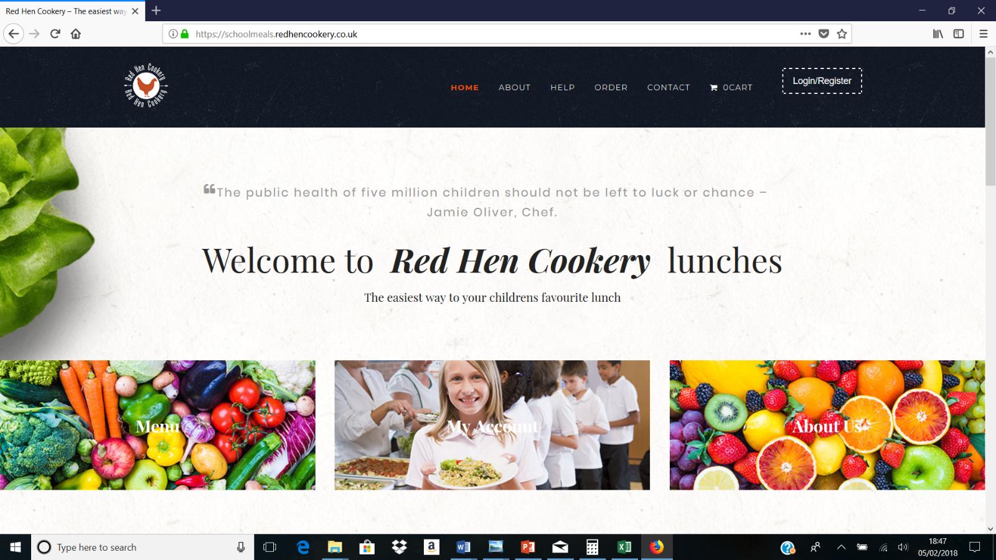
Click here to Register

A pop-up box will appear. You will need to select ‘Register’ to set up an account.

You should now be able to add your email address and choose a password. Once you’ve entered these details, click Register. You will now need to check your emails for a verification email. Once this comes through please follow the instructions to verify your email address and come back to Log in on our school meals ordering website. Now you can Log in with your verified email address and your chosen password. Please be aware that some email providers can take longer than others to process requests and also please make sure that you check your spam filters if you are having difficulty seeing the verification email. If you have not received your verification email within 48 hours email us (info@redhencookery.co.uk) and we will investigate.

Once you’ve Logged in you’ll be taken to your Dashboard, as below. Now you need to add your child/cildren’s details to your account, so that you can start ordering meals. Click ‘MY CHILDREN’ on the Dashboard to do this.

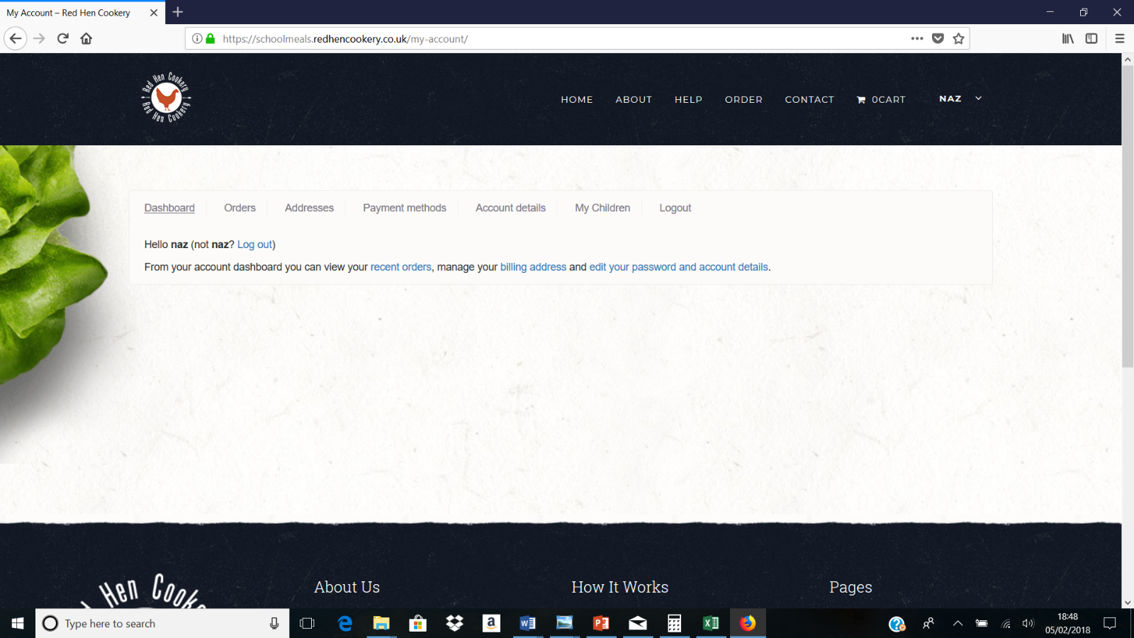
Click ‘My Children’ to add your child/children’s details

Now click ‘Add Child’
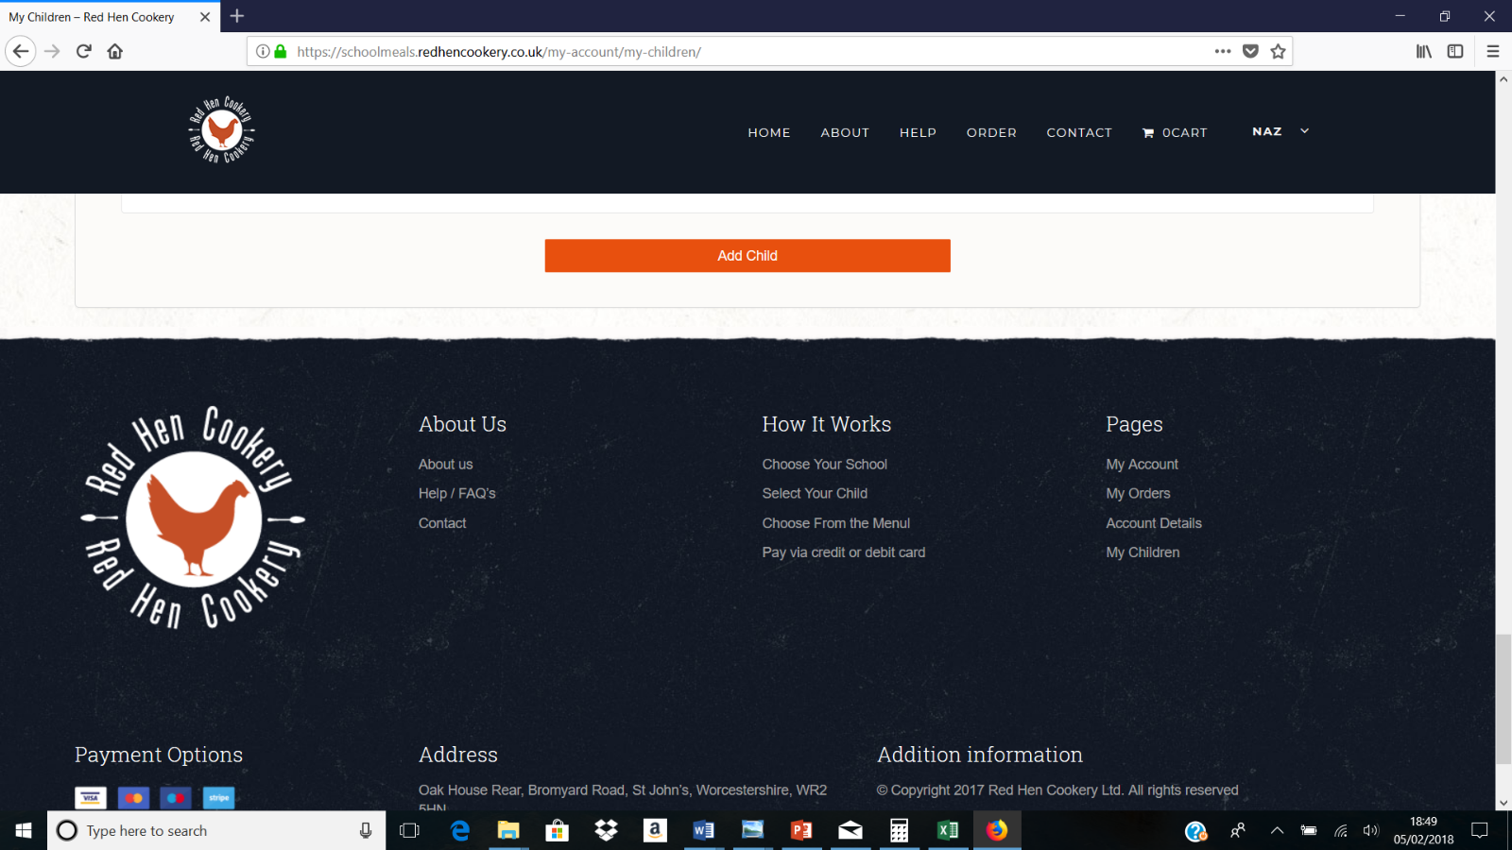

Now you can add your child’s details in this box (see below) , then click ‘SAVE CHILD’. If you need to add additional children you can follow the above step again by clicking ‘Add Child’ and adding another child’s details and clicking ‘Save Child’.

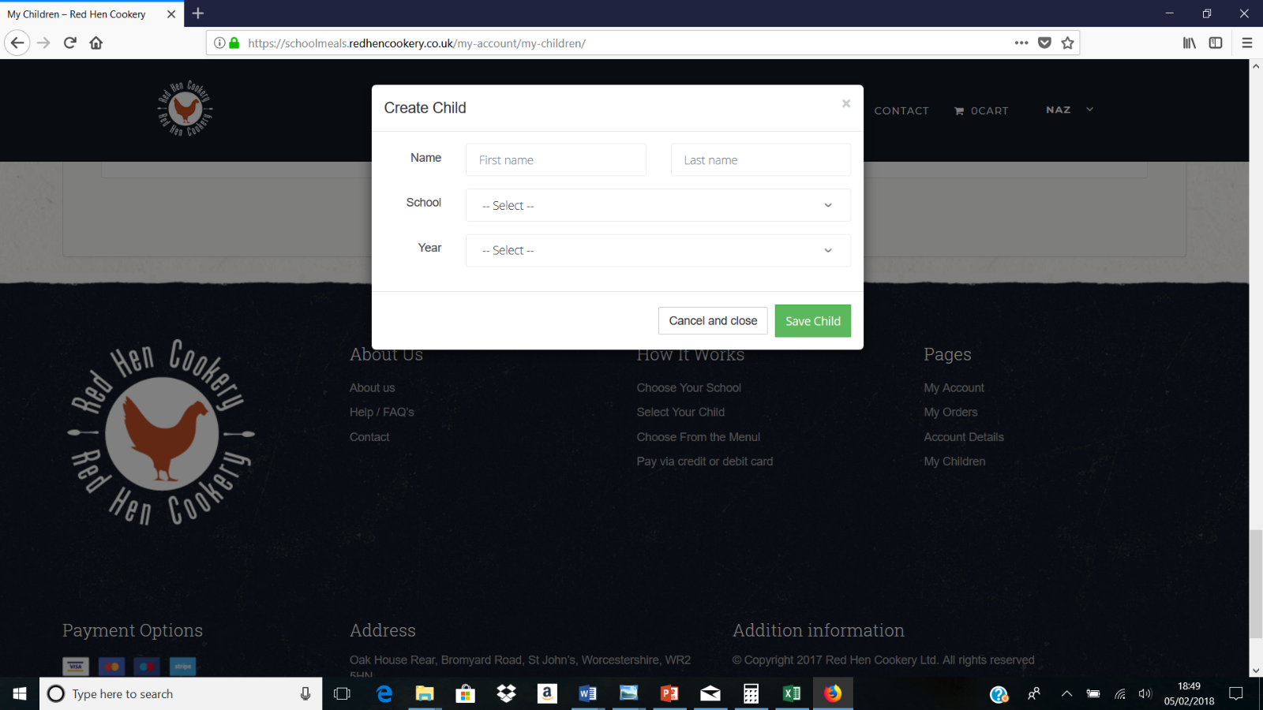

Once you’ve added your child/children, you can now start to place your first child’s order. Using the top tab bar, select ‘PLACE NEW ORDER’

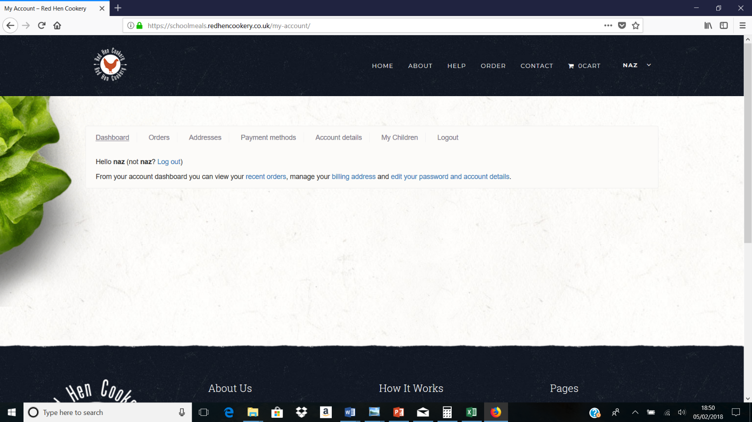

Choose the school your child attends from the list.

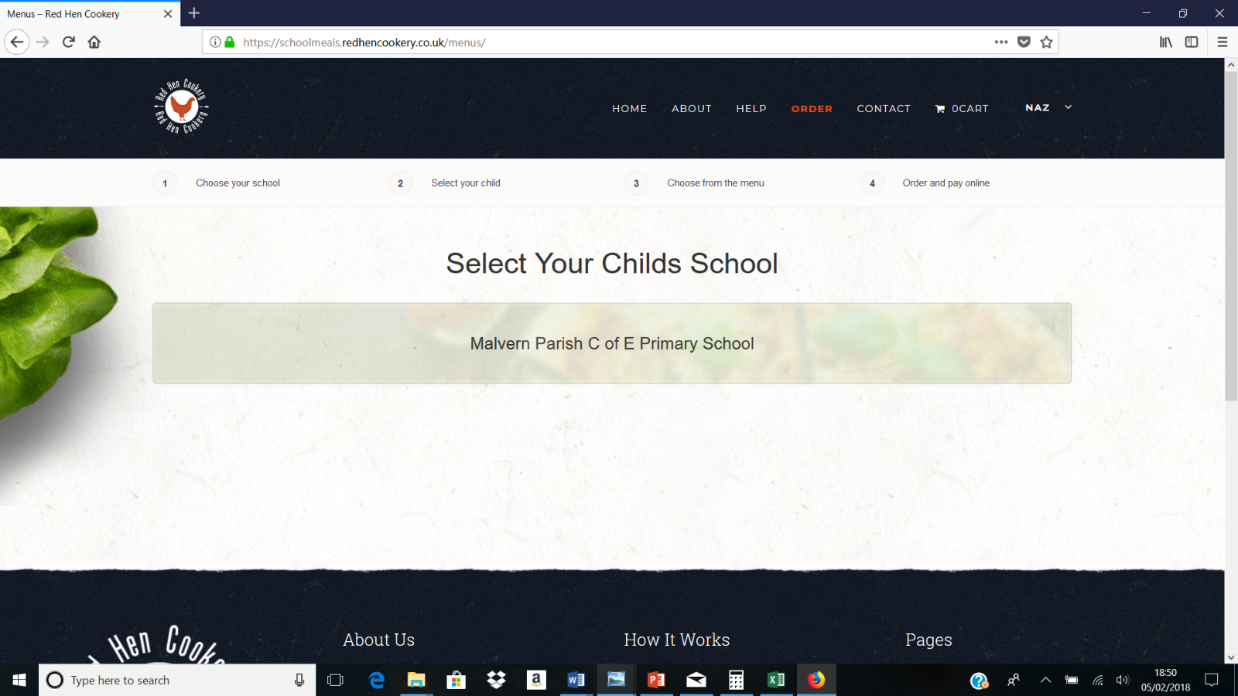
Click Here

Click on the name of the child you’d like to order for and scroll down the page to the current menu. If you fail to select a child before making your meal choices the system will not allow you to proceed further/leave the page.

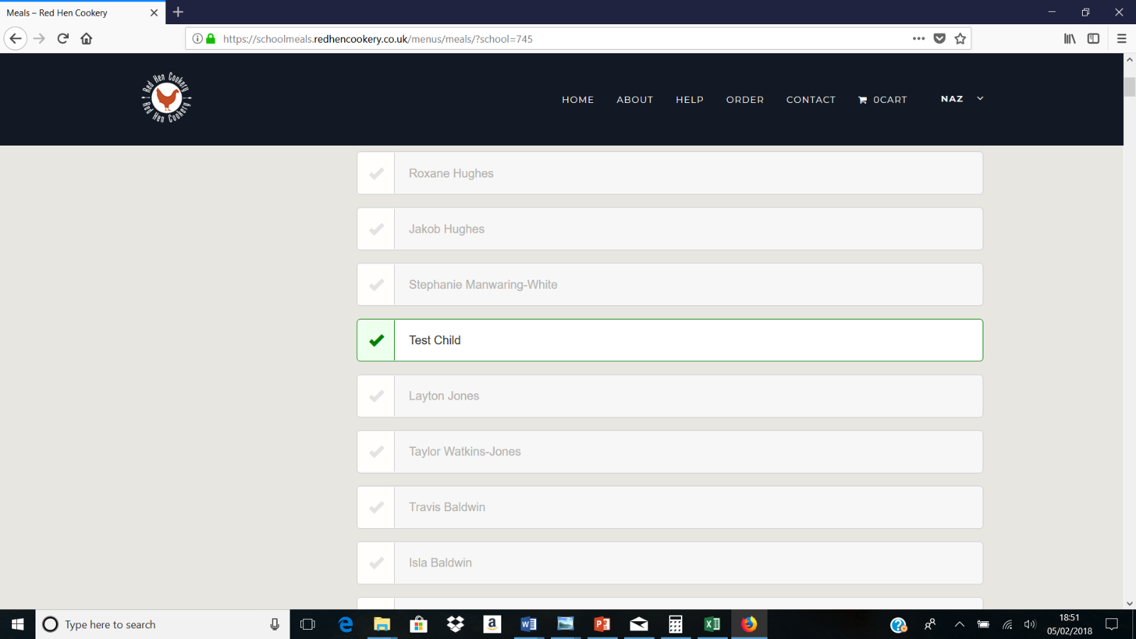

Once you scroll down you can start choosing the meals for the child you’ve selected. Don’t forget to select BOTH main meal AND a dessert each day. If your child’s school is one that has requested a packed lunch option be available then just click on the packed lunch of your choice. DO NOT select a dessert when selecting a packed lunch as it is already included in the bag. Each day you can choose from 3 main and 3 dessert options or three packed lunch options. If you have placed a tick in the wrong box just click in the correct box to change it.

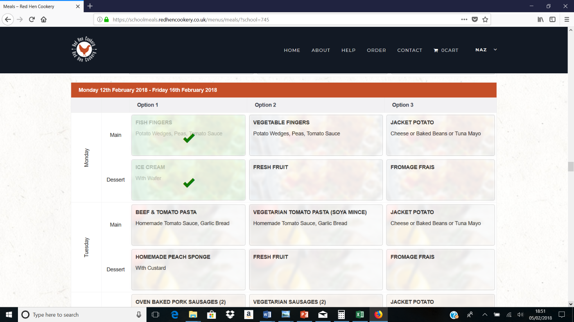
Start ordering your first child’s meals. You can order for just 1 day, a few days, a week or the whole term!

Once you’ve selected all the meals you’d like, scroll down and select one of the 3 options as shown below. If you’re child is in Reception, Year 1 or Year 2 our system will automatically recognise that they are entitled to a Universal Free School Meal and the box will already be prepopulated with a tick, you will not be charged for these meals.
If your child is in Year 3, 4, 5 or 6 and entitled to Means Tested Free School Meals (usually if you are in receipt of Universal Credit) please select this option. At the end of each month your child’s school will check this list so please only order a Free School Meal if your child is entitled otherwise your school will hold you liable for payment directly.
If your child has a food allergy please select this box which will then give you the opportunity to tick which allergy/allergies apply from the 14 food standard agency defined allergens. We will then ensure that your child receives a meal free from the allergy/ies selected.
Once you are sure everything is correct and filled in fully click on the link ‘PROCEED TO CHECKOUT’ at the bottom of the screen.

Now review and check your order, make sure you’ve ordered for just 1 child and that you’ve ordered a main and dessert or just a packed lunch for each day. Also check all your personal account details are correct and nothing has changed since you set up your account. For example if you have moved to a new address or have a new contact number or email address, etc.
If you need to change anything then click on ‘RETURN TO THE MENU HERE’ (in orange text). Please be patient as it may take a few moments to process and refresh the screen. Now change your choice on the date/s you wish to amend.
If you are paying for your meals then the total for the order will appear and you will be asked to complete your payment details. If your child is in Key stage 1 or you have selected free School Meals then the total will appear as £0.00.
If everything looks correct and you are happy with your choices, select the ‘PLACE ORDER’ tab on the page (below the list of ordered meals).

You’ve now placed your order!
After a few seconds you will be presented with a page titled: CHECKOUT: SUCCESS. You will also be issued with an order number.

Please be aware that any order is ONLY confirmed once you receive an email with all the details (see below image). If you do not receive an email the order has not been placed correctly. The confirmation email is your receipt but it’s also an excellent ‘at a glance’ record of when and what meals you’ve ordered for your child. You can also print this for ease of use.
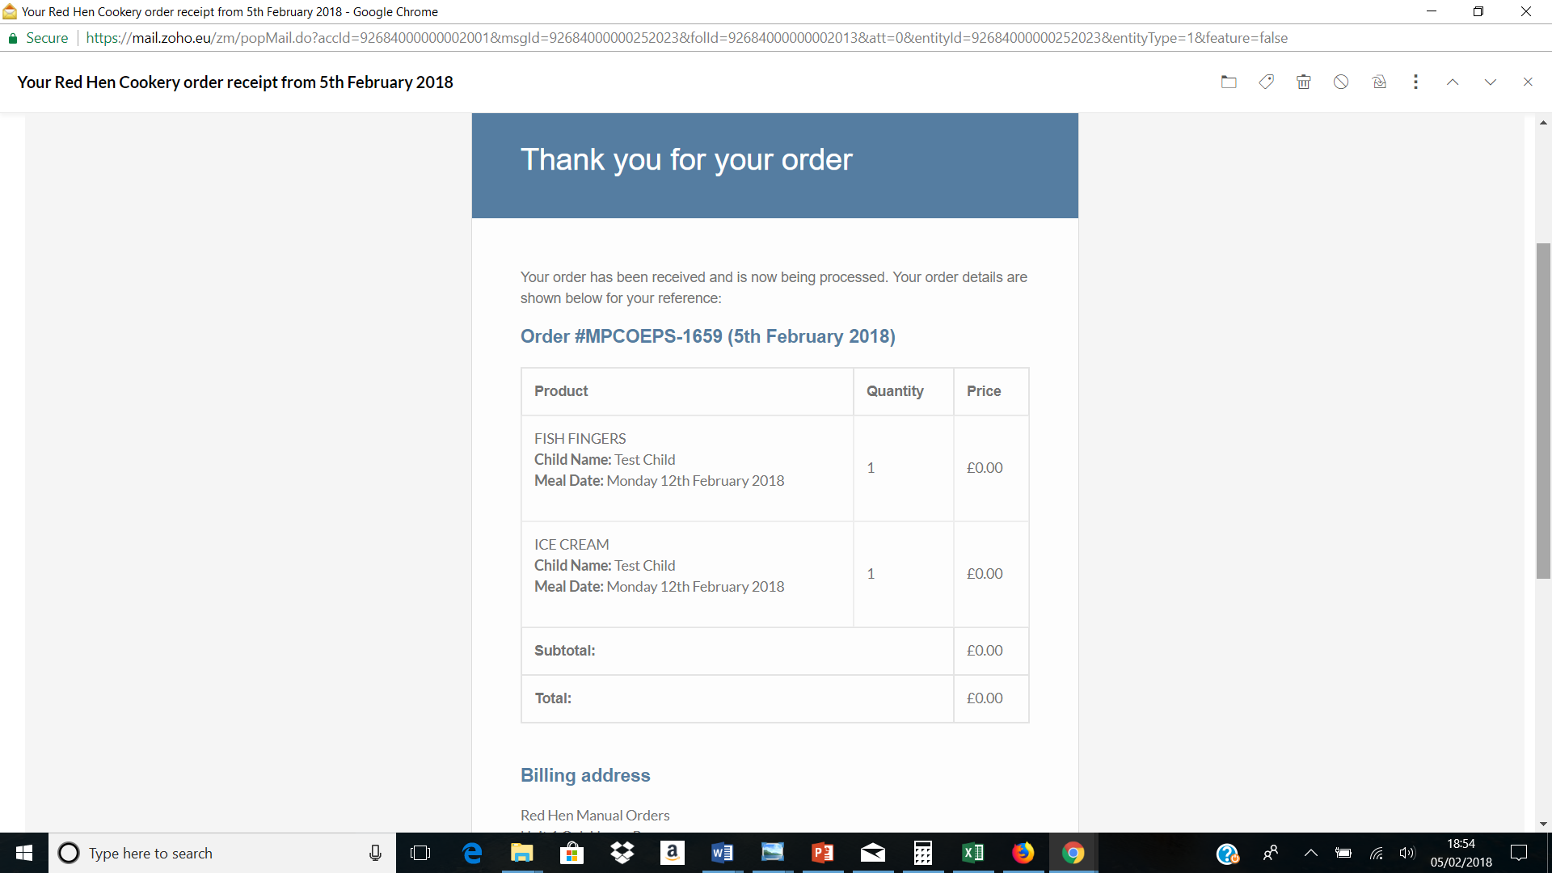

CANCELLATIONS AND AMENDMENTS
If you need to amend or cancel a meal you can do so.

Cancelling:
- Log on as per normal.
- Click on the ‘Orders’ tab on the home page.
- Click on the ‘View’ tab to the right of your latest order.
- Scroll down the list of meals till you see the date you want to cancel. Click on the ‘Cancel Item’ tab to the right of the meal. Now you will need to repeat for the dessert booked the same day. It is important to cancel both elements of the lunch in order to ensure a refund is issued where applicable and to reduce food waste. If cancelling a packed lunch there will be no dessert to cancel.
- Once everything you wish is cancelled just log off, there is no need to do anything else.

Amendments:
- Follow the same procedure as cancelling, including cancelling both the main and dessert choices. Make a note of the dates for any cancelled meals.
- Now place a new order for the ammended choices on the dates you have written down. Do not order anything else on the order just those items you have cancelled and wish to replace with a different choice.

We regret that we cannot accept any cancellations with less than 48 hours notice due to having already placed orders for ingredients with our local fruit, vegetable, meat and cheese suppliers.
We cannot keep any money on account so if you pay for your child’s meals we will refund the cost of the meals you’ve cancelled back to your original payment card automatically, subject to your meeting our cancellation timescales.

USING TABLETS OR SMART PHONES
If you are using a tablet or smart phone to place your orders please be aware that some tabs and screen layouts will differ from what is represented above. The best way to ensure the clearest information is viewed is to use your screen in landscape rather than portrait mode.
When registering your email address will be added to a list. This list is used to send reminder emails on a weekly basis. Also it is used to send reminders about ordering deadlines during the school holidays and is utilised if there is any important information regarding the operation of the ordering site that needs to be communicated to parents.
You can unsubscribe from this list when you receive your first email from us should you so desire. Please be assured that the list is only for our use and is not shared with anyone else.
If you have any questions or queries, please do email or call us – we are more than happy to help you. Email is the best choice as they are monitored outside of office hours (Monday-Friday 8am – 2pm term time only) and also during school holidays.
info@redhencookery.co.uk
Tel: 01905 422997

