Science: Biology
Milestone 3 - Biology - To understand plants(2 indicators)

Year Group/Class: Elm  Term: SummerTerm 2023 | Topic: Plants
Prior Knowledge/Teaching: (What does this unit build on?)
Milestone 1: Identify and name a variety of common plants, including garden plants, wild plants and trees and those classified as deciduous and evergreen. Identify and describe the basic structure of a variety of common flowering plants, including roots, stem/trunk, leaves and flowers. Observe and describe how seeds and bulbs grow into mature plants. Find out and describe how plants need water, light and a suitable temperature to grow and stay healthy.
Milestone 2: Identify and describe the functions of different parts of flowering plants: roots, stem, leaves and flowers. Explore the requirements of plants for life and growth (air, light, water, nutrients from soil, and room to grow) and how they vary from plant to plant. Investigate the way in which water is transported within plants. Explore the role of flowers in the life cycle of flowering plants, including pollination, seed formation and seed dispersal.
Lenses: What we want children to know (Curriculum) (Chris Quigley Objectives)  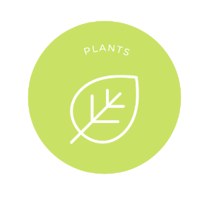  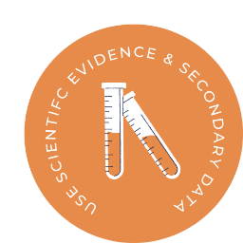 |  | Key Vocab  Adaptation, anther, botanist, botany, carbon dioxide, chlorophyll, compound leaves, deciduous, dispersal, environment, evergreen, family, filament, foliage, germination, habitat, horticulture, horticulturist, humidity, nectar, node, nutrient, oxygen, photosynthesis, pollen, pollination, reproduction, root, sepal, species, stamen, stem, stigma, tendril, transpiration, vein, vine.  Full Glossary for reference in pupil exercise books.

